International Fall Semester
2024

Geopolitics English Language

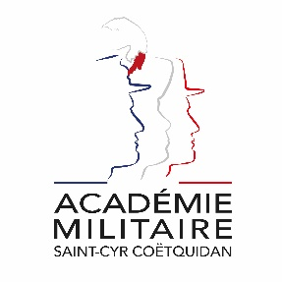
Military Academy of Saint-Cyr Coëtquidan

ERASMUS ID CODE | FGUER01
Contact | First Lieutenant (OF-1) OFFERLIN Charlie  Mail: cyr.international@st-cyr.terre-net.defense.gouv.fr  Phone: +33 2 97 70 73 75
Dates | Start: 16th September 2024  End: 17th January 2025  Arrival date: 11th September 2024 (Kindly respect this date)  Dates might evolve
Student Requirements | English language B2 or 785 TOEIC
Application file | - Application form  - Medical Certificate  - Reduced Medical Booklet  - ID or Passport scan  - 1 ID photograph  Applications must be sent no later than 30th June 2024.
Meals & Accommodation | According to EMILYO-LoD 5 (framework), accommodation, meals, and other expenses in relation to the education are free of charge for members of European Union Basic Officer Education Institutions (http://www.emilyo.eu/node/982).

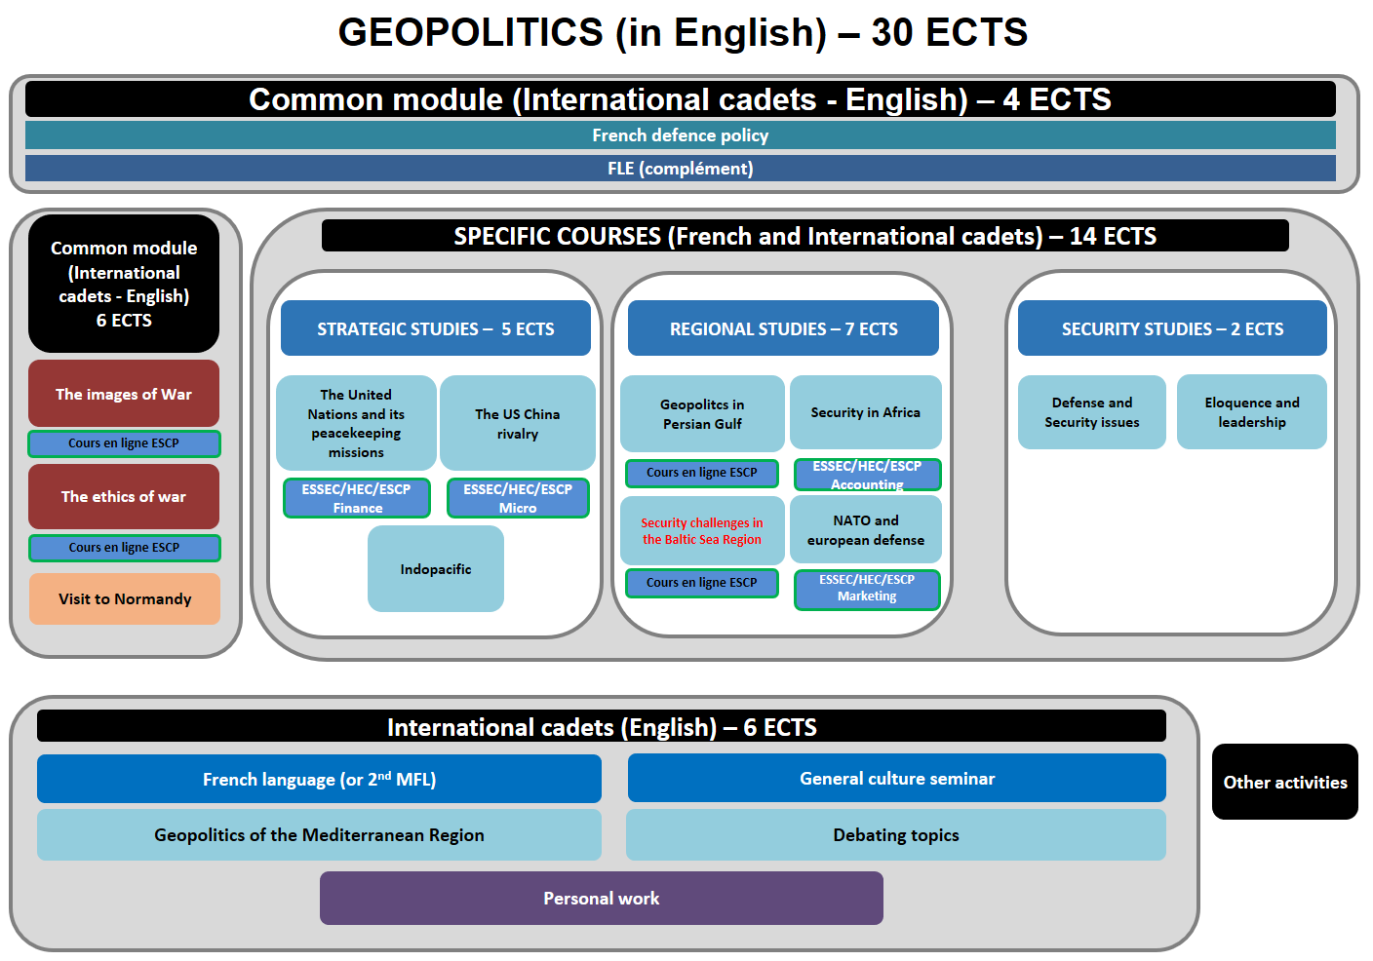

International Fall Semester 2024
Geopolitics and Security Studies (in English)

COMMON MODULE (international cadets – English)

- IMAGES OF WAR (Mrs. GOT)
The aim of the course is to discover the weight of representations on the conduct of war. What are the relations between the graphic arts and war? How have arts been used to the conduct of war? How have officers used their technical skills to represent military situations?
- ETHICS OF WAR (Mr. BOURGOIS)
The course is based on case studies. Military ethics can be about a wide range of things (aspects of military conduct, relations of military personnel with their civilian leaders, issues related to war…). For the purposes of this entry, however, the discussion will be limited to ethical questions concerning the use of military force for the redress of political disputes. As war becomes increasingly dominated by high technology weaponry (at least in the developed countries), there is an intimate link between developments in science and technology and the questions of appropriate military use of those advances as addressed by military ethics. Traditionally military ethics has emphasized an approach to just war thinking that has roots in classical and early-Christian sources. In post-Reformation and post-Enlightenment Europe, this ethical and religious tradition found secular and legal codification in the Laws of Armed Conflict (both in international law and in the specific military law of individual nations).
- FRENCH DEFENCE POLICY (Mr. BOURGET)
The course offers an overview of the French military. The various lectures focus on the current French Defence policy (including the most recent White Paper, and ongoing operations), the organization of the three services and their capabilities. A particular emphasis is laid on the Army (organization, recent engagements, equipment, Special Forces and the Foreign Legion).

SPECIFIC COURSES

STATEGIC STUDIES
- UNITED NATIONS PEACEKEEPING (Mr. TARDY)
The course offers a critical overview of United Nations (UN) Peacekeeping operations, their evolution over time, and the role they play in contemporary international peace and security governance. UN Peacekeeping operations were created during the Cold War as non-coercive tools to help establish peace in areas at the margins of the East-West confrontation. With the end of the Cold War, and that of the paralysis of the UN Security Council, UN Operations have adapted to the new security governance needs, both quantitatively and qualitatively. These evolutions have led to large and controversial operations, such as the ones in former Yugoslavia in the 1990s, but also to a peak of the UN presence in Africa in the 2000s and 2010s. UN Peacekeeping operations have always suffered from recurrent critiques about their military nature, political effectiveness, and ability to work with local actors. Most specifically, Western states have tended to stay away from these operations, leading to tensions between on the one hand states that decide and pay, and on the other hand states that implement peace operations’ mandates. Despite their many limitations, UN peace operations are indispensable tools of security governance.
- THE US-CHINA RIVALRY: FROM REGIONAL TENSIONS TO GLOBAL COMPETITION (Mr. LE CORRE)
The US China rivalry is very often mentioned as the very framework to understand the 21st century geopolitics. The objective of the course is to focus on the different fields and levels of the US-China race for global leadership: military tensions, new dynamics in Asia, global strategies, regional economic partnerships…
- INDOPACIFIC (Mr. VINATIER)

The aim of the course is to have a study in depth of both concept and reality by focusing on main actors: states such as the US, China, India, Japan, Australia, France and the EU; regional organizations; TransNational Companies; NGOs and transnational organized crime. They key issues will be regional order, strategy and vision, diplomacy, policies, cooperation and integration, military tensions, piracy, terrorism, energy resources, natural resources, major shipping routes, submarine cables, migration patterns and remittances. The methodology is based on many case-studies of sub regions and strategic chokepoints: the Malacca Strait, the Taiwan Strait, the South China Sea, the East China Sea, the Indian Ocean, the horn of Africa and the Strait of Bad-el-Mandeb, the Strait of Hormuz, the Indian subcontinent, Australia, New-Zealand and the Pacific islands. Teamwork, cooperative spirit and team communication skills will be required.

REGIONAL STUDIES

- THE GEOPOLITICAL TRANSFORMATION OF THE PERSIAN GULF: TENSIONS, COOPERATION AND NEW CHALLENGES (Mrs. SOUBRIER)
The aim of the course is to have a study in depth of the dynamics of change in the Persian Gulf by focusing on Saudi Arabia, the UAE, Qatar or Iraq but also on the alliances and partnerships with other actors outside the region. Some of the key issues will be political and military security in the region, arms trade, cooperation and governance, challenges and opportunities, influence of both China and the US.
- SECURITY IN AFRICA (COL JOVANOVIC)
The course is about the many security aspects of the African continent. It focuses on military issues in different areas like Western Africa or the Horn of Africa. It also insists on current dynamics: radicalization, terrorism, jihadism, political instability, border conflicts, resources management, food security or climate change. It will encompass the logics of players in international relations: local and federal authorities, foreign powers (the US, the UK, France, Russia or China), the international community (UNO, UNHCR, UNICEF), NGOs or TNCs.
- SECURITY CHALLENGES IN THE BALTIC SEA REGION (Mr. VIDAL)
Since the Middle Ages, the Baltic Sea has been a key geopolitical battleground in Northern Europe. Highlighting the history of this area, the course delves into the post-Cold War context to the ongoing geostrategic transformation in the 2020s. It includes regional state defense and strategic policies (Baltic States, Belarus, Finland, Poland, Russia and Sweden) as well as key security actors (NATO, EU, and other relevant partners). In light of Russia’s full-scale invasion of Ukraine, security tensions in the Baltic Sea are on the rise due to a large number of incidents and provocative actions led by Moscow (e.g. border frictions, GPS jamming, military deployments, shadow tanker operations, etc.). Special attention will be paid to key hotspots such as Kaliningrad, Gotland, and the Åland archipelago. Ultimately, this course aims to provide cadets with a comprehensive overview of the current and future challenges in this critical European region.
- NATO AND EUROPEAN DEFENCE (Mr. TARDY)
The course deals with the North Atlantic Treaty Organisation (NATO), its post-Cold War evolution, current mandate and challenges. It looks at how the Atlantic Alliance has adapted to the evolving security agenda, from its embrace of crisis management in the immediate post-Cold war era to counter-terrorism in response to 9/11, and back to collective defence as of 2014 and the Ukraine crisis, and then war. The Course also looks at national policies towards NATO (in particular the United States’ and France’s), the relations between NATO and the European Union, and how NATO’s relevance and cohesion have been impacted by various political and operational developments. The on-going war in Ukraine is also examined as it determines both the current agenda of the Alliance and its future role in the to-be-established European security architecture.

SECURITY STUDIES

- ELOQUENCE AND LEADERSHIP (Mrs. McDERMOTT)
Cadets will work eloquence with an English language trainer, a public speaking specialist and image consultant: communication, personal image, charisma, and team building.
- DEFENCE AND SECURITY ISSUES (Mr. VINATIER)
The Course deals with defence and security issues in the Indian subcontinent. It looks at the dynamics and geopolitical issues of both the Indian Subcontinent and the Indian Ocean (India, Pakistan, Bangladesh, Sri Lanka, Maldives, Mauritius…). The Course also looks at foreign policies, the relations between China, the US or even European powers and the Indian subcontinent. The on-going border issues between India and China are examined as they determine India’s positioning in international relations.

INTERNATIONAL CADETS SPECIFIC COURSES

- FRENCH LANGUAGE
The French language course is adapted according to the level of the student. Beginner courses, aim to familiarize with the basics of written and oral French language, through targeted and personalized exercises. Confirmed levels, enable students to strengthen their linguistic skills, through exercises and the study of authentic audio and written documents (films, programs, articles, books). For both levels, the aim of this course is to provide students with notions of civilization and contemporary French culture.
- GENERAL CULTURE SEMINAR
The course offers an introduction to French culture through a mix of lectures and interactive presentations. The latter focus on French history (historical figures and landmarks), geography (continental France and French overseas territories), politics, arts and art de vivre. The objective is to make foreign cadets more familiar with the specific challenges French society is facing, and allow them to understand their allies a little better.
- THE GEOPOLITICS OF THE GREATER MEDITERRANEAN: NEW DYNAMICS AND NEW CHALLENGES (Mr. VINATIER)
The course is mainly about focusing on the new dynamics in the Mediterranean region, the new Mediterranean framework and the main regional players (the European Union, Turkey, Israel, Egypt…). Some of the key issues will be political and military security in the region, energy trade, cooperation and governance, environmental challenges and economic opportunities. Teamwork, cooperative spirit and team communication skills will be required.
- DEBATING TOPICS (Mr. BOURGET, Mrs. GARREC and Mr. VINATIER)
The aim of the course is to have courses organised like debates with separate groups defending different perspectives on many topics concerning France and European countries. Controversial issues will be addressed. Some of the key issues will be security in France and the role of the French institutions. The course also deals with counter-terrorism, crowd control, cooperation and governance. Teamwork, cooperative spirit and team communication skills will be required.

Application file documents:

- Application Form (p.7)

- Medical Certificate (p. 8)

- Reduced Medical Booklet (p. 9 – p.10)

Application Form

Military Academy of Saint-Cyr Coëtquidan
Please attach your head-and-shoulder photograph data.
Country of Origin:
Name of the Institute:

Course selected:
Geopolitical Science (ENG)
Geopolitical Sciences (FR) – Major: _____________________________
Science (ENG)

Male | Female | Rank | Surname | First name

Date of birth | Place of birth | Branch of Service | Major academic Field | Academic Year

Passport number | Phone number | e-mail address
ID number | Current address

Arrival at Rennes Airport (yes/no) | Arrival at Rennes rail station  (yes/no) | Arrival date (dd/mm/yy) | Time of arrival
Departure from Rennes Airport  (yes/no) | Departure from Rennes rail station  (yes/no) | Departure date (dd/mm/yy) | Time of departure

Special dietary or food requirements

Emergency contact/ Liaison staff:
Male | Female | Rank | Surname |  | First name
POC’s phone number |  |  |  | POC’s e-mail address
FRENCH MINISTRY OF DEFENSE

-------------------------
MILITARY HEALTH SERVICE

--------------------------
MEDICAL CERTIFICATE
(n°620-4/1)

SURNAME: FIRST NAME:

Birth date: Rank:

APTITUDES | Medical decision
General

Abroad & overseas

Paratrooper

Commando

Job’s restriction details
(if needed)

CONCLUSION: Date:
⁭ Aptitude without restrictions
⁭ Aptitude with restrictions Practitioner’s signature & stamp:
⁭ Inability

Reduced Medical Booklet

Surname: First Name:

Birth Date: Rank:

Medical Background
- Family:

- Medical:

- Surgical:

- Allergy:

Treatment:

Current Medical condition:

Job’s incapacity:

Height: Weight:

Blood Pressure: Pulse:

VACCINES:

TYPE | Date of 1st injection | 2nd injection | 3rd injection
BCG
Diphtheria-Tetanus-Polio-Pertussis
Meningitis (A + C)
Hepatitis B
Measles-Mumps-Rubella
INFLUENZAE (H1N1 and seasonal)
Meningococcal Tetravalent (A + C + Y + W135
Typhoid
Hepatitis A
Yellow fever

Date: Practitioner’s stamp and signature:

